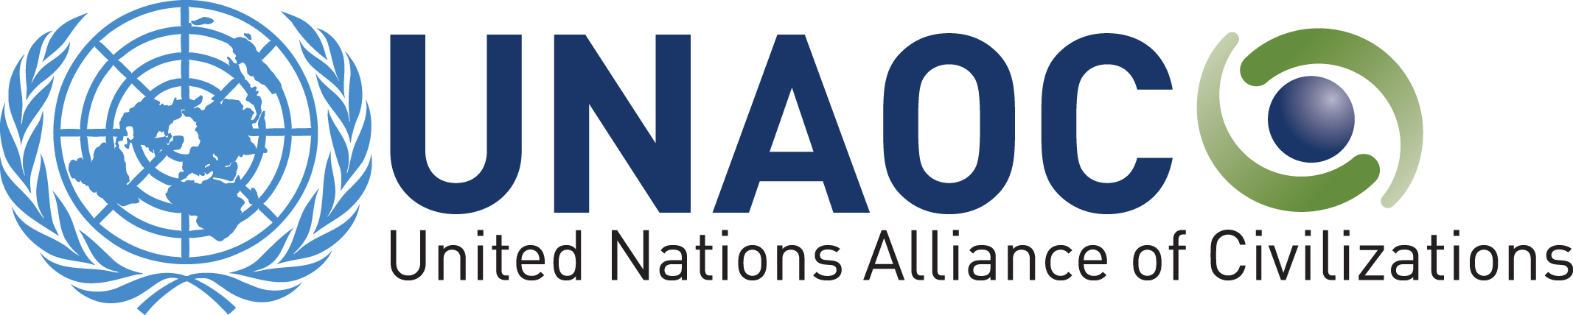

Draft Outcome

ANNUAL UNAOC FOCAL POINTS MEETING AND PREPARATORY CONFERENCE FOR THE SIXTH UNAOC GLOBAL FORUM

APRIL 29-30, 2014
DOHA - QATAR

We, the representatives of the Group of Friends of the United Nations Alliance of Civilizations participating here in Doha – Qatar in the Annual UNAOC Focal Points Meeting and Preparatory Conference For The Sixth UNAOC Global Forum;
Reaffirming our commitment to the purposes and principles of the Charter of the United Nations, the Universal Declaration of Human Rights, as well as other relevant international instruments, including UNESCO’s Universal Declaration on Cultural Diversity;

Acknowledging United Nations’ General Assembly Resolution 64/14 of 10 November 2009, adopted by consensus, which recognizes and welcomes the efforts of the United Nations Alliance of Civilizations and expresses support for its practical projects;

Recalling General Assembly resolution 36/55 of 25 November 1981, proclaiming the Declaration on the Elimination of All Forms of Intolerance and of Discrimination Based on Religion or Belief, and reaffirming the subsequent General Assembly and Human Rights Council resolutions on freedom of religion or belief and on combating intolerance, negative stereotyping and stigmatization of, and discrimination, incitement to violence, and violence against persons based on religion or belief, including United Nations Human Rights Council Resolution 16/18 of March 2011;

Recalling previous UNAOC outcome documents and declarations including the Ministerial Declaration adopted in September 2013;

Welcoming United Nations General Assembly resolution 67/104 of 17 December 2012, which proclaims the period 2013-2022 as International Decade for the Rapprochement of Cultures and which offers Member States an opportunity to enhance their activities relating to interreligious and intercultural dialogue, promoting tolerance and mutual understanding;

Acknowledging the leadership and contributions of the members of the Group of Friends, in particular the founding co-sponsors Spain and Turkey, as well as the other previous host countries of UNAOC Global Forums, Austria, Brazil, and Qatar;

Recognizing the role of national parliaments and their active contribution at the international and regional levels through the process of soft diplomacy, for the achievement of the goals and mission of the UNAOC for the benefit of all citizens;

Reaffirming our support for the UNAOC and its High Representative;

Emphasizing the importance we attach to the continued efforts of UNAOC in increasing mutual respect among persons belonging to different religious and cultural groups;

Saluting regional processes to increase intercultural dialogue and cooperation among countries, in particular:
o the presentation of the 2nd Action Plan for the Mediterranean;
o the Fez Program of the Parliamentary Assembly of the Mediterranean aimed at fostering mutual cooperation and understanding amongst the Parliamentary Assembly for the Mediterranean Member States and the Mediterranean region as a whole;
o the 2nd Action Plan for South-Eastern Europe;
o the conclusions of the 2nd Regional consultation for Asia/South Pacific;
o the presentation of the Regional Strategy for Latin America endorsed by Ministers and representatives of the region;
o the launch of a regional debate on the Danube and Black Sea Region, the Southern Caucasus and Central Asia, and;
o the announcements by the League of Arab States and the African Union of their intention to work with their member states to develop their own regional strategies.

Recognizing the pioneering role of the UNAOC in mainstreaming its four pillars, namely; Youth, Education, Media, Migration as well as the role of new focus areas designated by the High Representative such as Sustainable Development, Arts, Sport and Entertainment as human expressions participating in global efforts of cross-cultural agenda and broader United Nations processes;

- Reiterate our support for the priorities of the High Representative, his Strategic Plan (2013-2018); and reaffirm our commitment to the four pillars of UNAOC activity identified in the High-level Group Report, specifically Youth, Education, Media, and Migration as well as the new focus areas identified by the High Representative;

- Support the High Representative to continue programming within these recognized four pillars of activity as well as in other aspects underscored in the High-level Group Report, with a view to advance UNAOC’s ability to serve as an instrument for preventing violence and fostering reconciliation, in particular, in the context of identity-based tensions and conflicts;

- Stress the continuing need for UNAOC to highlight the importance of culture as an element in the post 2015 development agenda and to appropriately integrate socially inclusive approaches in development programming;

- Support the implementation and development of Regional Strategies to increase cooperation among countries and organizations on intercultural dialogue, with the active leadership of the High Representative, multilaterals and governments in collaboration with civil society;

- Stress the importance of implementing the Alliance’s goals at a national level through the implementation of actions at country level or through National Strategies for intercultural dialogue, with the active leadership of governments in collaboration with civil society;

- Welcome the sixth annual report of the UNAOC;

- Mindful of the increasing visibility of the UNAOC including among the UN system and its collaboration with other agencies, departments and its increasing interaction with the Group of Friends and civil society organizations;

- Emphasize the close link between the values and goals of the UNAOC and democratic processes and express support for the strengthening of this link through the projects and activities of the Alliance;

- Recognize the nexus between peace, stability and Sustainable Development on the basis that stable environment is conducive to prosperity and Human Rights;

- Support the role of the UNAOC as an advocate and promoter of new and creative approaches that advance intercultural and interreligious dialogue across sectors with the active participation of both men and women;

- Acknowledge the significance of the continued financial commitments made by Group of Friends, as well as other forms of support, and stress the ongoing need for the continuation of such financial support;

- Emphasize the importance of the Global Forums, involving the Group of Friends and partners, together with leading personalities of various areas, including the upcoming 2014 Global Forum in Indonesia “unity in Diversity”;

- Express appreciation to the State of Qatar for the generous hosting of this conference and efficient organization.

######
For further questions and information related to the outcome, delegations may contact Mr. Tariq Al-Ansari, Chief of Cabinet at:
Al-AnsariT@un.org or +16467523808

